Draft Harrow Borough Plan 2030

Harrow – the borough we are proud to call our home
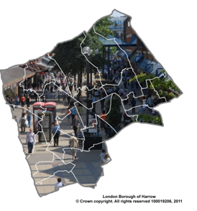
Harrow Council | Metropolitan Police | London Fire Brigade
London North West University Healthcare NHS Trust | Central & North West London Mental Health Trust | Central London Community Healthcare NHS Trust
Harrow Health CIC | Harrow College | Home Group
Harrow Clinical Commissioning Group  Harrow Community Action | Harrow Voluntary & Community Sector Forum  Voluntary Action Harrow | Young Harrow Foundation
The Borough Plan is a partnership plan for Harrow. Through further engagement we intend to engage more partners, businesses and residents in supporting and delivering the plan. Current partners supporting this plan are:

Leaders Introduction
We are proud of Harrow and what it has to offer as a great place for families to thrive. Through developing our Borough Plan 2030 we want to set out our aspirations for the borough we are happy to call home: with a focus on tackling inequality and disadvantage.
We need to look beyond the short term, recognise our strengths and face up to the challenges, demonstrating a commitment to delivering on these as a borough. To do this we will work in partnership and lobby others to play their role for our communities. In this draft Borough Plan, we set out these challenges and intend to spend 2020 as a year of engagement to obtain genuine input from our residents, businesses and partners to focus these priorities. We will then publish our finalised Borough Plan in February 2021.
While setting bold aspirations for the future, we have faced ten years of funding cuts as part of the Government’s austerity programme, which has had a real effect on our residents and our frontline services. It is important to recognise though, that austerity remains with us across the public sector and we will face very serious funding challenges. However, we are focussed on ensuring that we get the basics right, across the borough: addressing the impact of these cuts where we can and levelling up our communities to address inequality. We will work tirelessly to ensure that our neighbourhoods are well-maintained and great places to live, that we address the challenges of fly-tipping, increased numbers of illegal Houses of Multiple Occupation (HMOs) adding to waste on our streets and that more people are able to feel safe as they live or work in any of our neighbourhoods. To achieve this, much of our focus will be geographically based.
We want to ensure that what makes Harrow a great place to live is recognised and protected as we build more housing to meet growing demands. We are going to face up to our challenges such as tackling poverty to ensure that we are able to reduce inequality and end child poverty within the borough by 2030. We will address the climate emergency, taking the borough on a journey to becoming net-zero carbon during the life of this plan: to do this we will need the support of residents and businesses to identify opportunities and a collective approach, which will be a key focus for our engagement in the next year.
As well as addressing these challenges, we want to build on strong foundations for the future, recognising the success of our schools and education systems as well as celebrating our diverse and cohesive communities. The cultural diversity of our borough is one of our great strengths and we want to ensure that this is enhanced following our departure from the European Union.
Over the next year we will be consulting with and engaging our residents, businesses and partners to help inform the actions that we collectively need to take to turn this plan into reality. We want to ensure that this is a wide reaching and inclusive engagement process, informing our Borough Plan and many of our key strategies which will be important in delivering the improvements.
We are already working with a number of partners to develop our plan and look to extend this partnership with public, private, voluntary and community sector partners as well as ensuring that our residents and communities are key partners in delivering these ambitions.
I am proud on behalf of the partnership to present this draft Borough Plan. We hope that everyone will take the opportunity to respond to our consultation and help inform our priorities and actions.
Graham Henson
Leader of the Council

Contents
Leaders Introduction 2
Introduction 6
Tackling Inequality and Disadvantage 7
Our Vision and Priorities 7
Vision 8
Priorities 8
Our Borough: Our Community 9
Our Local Context 10
Priorities and Outcomes 13
Improving the Environment and Addressing Climate Change 13
Our data tells us 13
Our proposed objectives 14
The ‘Big Idea’ 14
How we will deliver our objectives 14
Tackling Poverty and Inequality 15
Our data tells us 15
Our proposed objectives 16
The ‘Big Idea’ 16
How we will deliver our objectives 16
Building Homes and Infrastructure 17
Our data tells us 17
Our proposed objectives 18
The ‘Big Idea’ 18
How we will deliver our objectives 19
Addressing Health and Social Care Inequality 20
Our data tells us 20
Our proposed objectives 21
The ‘Big Idea’ 21
How we will deliver our objectives 21
Thriving Economy 22
Our data tells us 22
Our proposed objectives 23
The ‘Big Idea’ 23
How we will deliver our objectives 23
Sustaining Quality Education and Training 24
Our data tells us 24
Our proposed objectives 24
The ‘Big Idea’ 24
How we will deliver our objectives 24
Celebrating Communities and Cohesion 25
Our data tells us 25
Our proposed objectives 26
The ‘Big Idea’ 26
How we will deliver our objectives 26
Maintaining Low Crime Levels and Improving Community Safety 27
Our data tells us 27
Our proposed objectives 27
The ‘Big Idea’ 27
How we will deliver our objectives 28
Next Steps 29
Short term delivery plan 29

Introduction
This is our draft Borough Plan 2020-2030 for consultation and engagement over the course of 2020. It has been developed in partnership with some of the key public sector providers in the borough and representatives from the voluntary and community sector. The Plan sets out aspirations for the borough over the next decade, recognising that there will be significant change over that period, some of which can be predicted: much of which cannot.
We have a clear vision of our borough and are building a strong partnership to deliver this to make significant improvements for the borough over the next decade. We want to focus on:
- Improving our towns for living, shopping and entertainment
- Narrowing the gap in healthy life expectancy
- Reducing inequality in earnings, attainment and opportunity
- Achieving net-zero carbon emissions across the borough
- Building 3,000 more affordable homes
We want you, as residents, businesses, communities and other interested parties, to join us in developing this vision and turning it into reality.
While focussing on the long term aspirations, we are also addressing the short term challenges in building communities which people are proud to call home. To achieve this, over the next year the council is investing £1m into some of these areas including: street sweeping; enforcement of fly tipping and Houses of Multiple Occupation; district centre projects; ward priorities; community cohesion; school improvement; and the Council Tax Support Scheme. This will strengthen the foundations upon which our bold aspirations for the borough are built.
For the longer term, within this draft plan we set out our priorities along with a series of objectives we want to achieve during the life of the Plan: these will be reviewed frequently during the next ten year implementation period. Much of what we seek to do relies upon others to deliver, or support delivery, meaning that we will need to work with and influence others to enable achievement of our ambitions for Harrow – this will include influencing and lobbying government at a regional and national level. There is also a strong role for individuals and communities in delivering this plan: we need a collaborative model and your help in caring for your own welfare and your areas. We will all have a role in caring for our people and caring for our place.
Although this plan is for the borough as a whole, many of the actions will be targeted to focus work on those areas most in need: tackling inequality and disadvantage for the benefit of everyone. There are significant challenges within the east of the borough, particularly around Edgware where many environmental and quality of life improvements are required. Wealdstone is the focus for concerted action with regeneration and house building on large sites, whilst there have been improvements and large numbers of new homes Harrow town centre. Further regeneration and development of the borough is an underpinning feature of our plans as we ensure the provision of affordable homes and meet our new housing targets.
To deliver our plan, we want to ensure that we collectively take care of our people and we take care of our place – creating a community and an environment we can be proud of. This plan is about encouraging and enabling individuals and communities to do more for themselves: reducing demand on public services and our environment rather than public services continuing to respond to an increased demand. Where possible, we will adopt a preventative focus as opposed to spending more to tackle issues that have arisen. By taking this approach, we can support the creation of a sustainable borough where families may thrive, now and in the future.

Tackling Inequality and Disadvantage
The Council and our key partners propose that the main issue we tackle over the next decade is inequality. This will become a recurring theme throughout the Borough Plan and across our partnership. Through engagement over the next year we want to ensure that our approach to tackling inequality and the key objectives and success measures we propose resonate with our community. This is our chance to understand resident’s views on this as an overarching priority as well as refine the measures we are currently considering.
Through a relentless focus on inequality and disadvantage we intend to continue to make Harrow a better place for all of our residents and businesses. Working with partners and listening to feedback we will fully develop our key measures to monitor progress in addressing inequality. Key measures we are considering focus on:
- Ending child poverty
- Reducing health inequality
- Raising English language skills
- Narrowing the educational attainment gap
- Reducing numbers in low paid employment
- Lowering unsecured debt levels
- Reducing the proportion of income spent on priority expenditure
Addressing these issues will help to ensure that local businesses have better skilled people to recruit from, that there is less crime and fewer people causing anti-social behaviour as they are able to work in more fulfilling roles, better support their families and contribute to society.

Our Vision and Priorities
Within Harrow, we are serious about making the borough a great place we are all proud of and in which families flourish. We are therefore committed to ensuring that our plan is relevant to children, young people, adults and older people. To do this, we recognise that there are many challenges to face. We acknowledge that there is a rapidly growing older population and respect that children and young people are the future adults of our borough: we will make sure that their voices are heard and influences our proposals. Without them seeing and helping set the vision, it is less likely that they will remain in the borough, or return after university. We are setting out a bold Borough Plan through to 2030 which will deliver strong and positive outcomes for our residents, businesses and our environment for future generations to enjoy.
This plan cannot be based on today’s norms, but must be radical and challenging if we are to rise to the needs and aspirations of the local community: residents and businesses. Whilst being bold, we cannot deliver this on our own and require the support and commitment from a range of stakeholders. We will pool our resources and effort to deliver, influence and enable others to meet our shared vision for the borough.

Vision
Whilst Harrow is a great place to live and work, many people feel that it lacks an identity. We propose to work over the next year to create a vision which demonstrates why we are proud of Harrow and set out aspirations for the partnership across the borough, encapsulating our sense of community, including:
- Everyone looks after each other
- Neighbourliness and cohesiveness
- Sense of belonging
- Caring for people and the area
- Resilience
This will set a focus for how we want to work within Harrow to be a diverse and high-achieving place where everyone can feel at home: caring for each other and our environment. We seek to retain our many strengths, but also collectively tackle the challenges we face as a borough.
In delivering our vision for Harrow, we want to ensure equality of opportunity for all of our communities and minority groups who contribute significantly to the diversity and culture within the borough. We want to ensure that Harrow is accessible to all.

Priorities
We have worked with partners to develop collective priorities for the Borough, based on feedback received from the people of Harrow in our annual resident’s survey. These priorities are set out below.
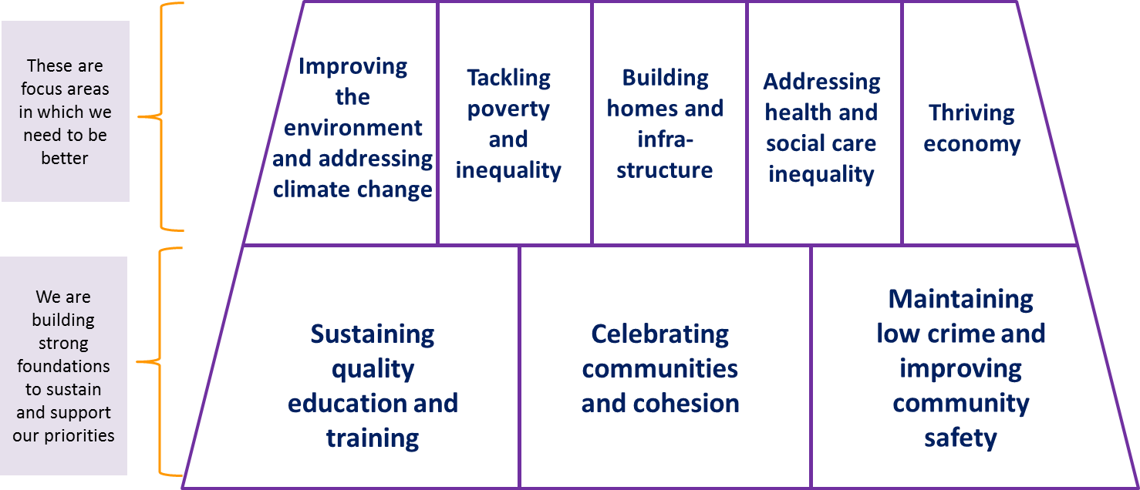
There are three areas, which form the foundations for addressing our main priorities, where we seek to maintain the standard of current provision:
- Sustaining quality education and training
- Celebrating communities and cohesion
- Maintaining low crime levels and improving community safety
We have five priorities where there are significant challenges to deliver the desired outcomes:
- Improving the environment and addressing climate change
- Tackling poverty and inequality
- Building homes and infrastructure
- Addressing health and social care inequality
- Thriving economy
This is really important to us in ensuring that everyone is able to live healthy lives, achieving to the best of their ability whilst we protect and restore the environment: preserving the planet for future generations.
Having set the context and laid out our priorities, we will delve into these in a bit more detail, giving an indication of the reasons these have been selected, some of the key outcomes we want to achieve and what we are seeking to address in doing so.

Our Borough: Our Community
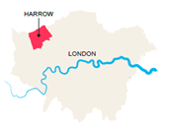
Harrow is an outer London Borough in North West London, approximately 10 miles from central London. Covering 50 square kilometres (20 square miles) and it is the 12th largest borough in Greater London in terms of size and 20th in terms of population. There are nine district centres, plus Harrow Town Centre which is one of London’s twelve metropolitan centres. Much of the population growth is within our main towns of Harrow, Wealdstone and Edgware, with a less densely populated area to the north of the borough which is home to smaller towns and villages. The borough benefits from fast links into central London, served by over ground trains and three tube lines.

Harrow is a great place: we are the safest Borough in London; one of the most diverse places in the country; a suburb with bountiful green space with just over a quarter of the area (over 1,300 hectares) consisting of open space, yet incredibly well-connected to a global airport hub and the centre of the world's greatest city.

The borough has three electoral constituencies: West Harrow; East Harrow; and Ruislip, Pinner & Northwood served by a Labour and two Conservative MPs, respectively. The borough is divided into 21 wards, each served by three directly-elected members, though this will change at the next local government election following the boundary review with the introduction of 2 and 3 councillor wards. We currently have a Labour administration with 35 elected members and the opposition comprises 28 Conservative members. Of the total of 63 members, 26 are women.

Our Local Context
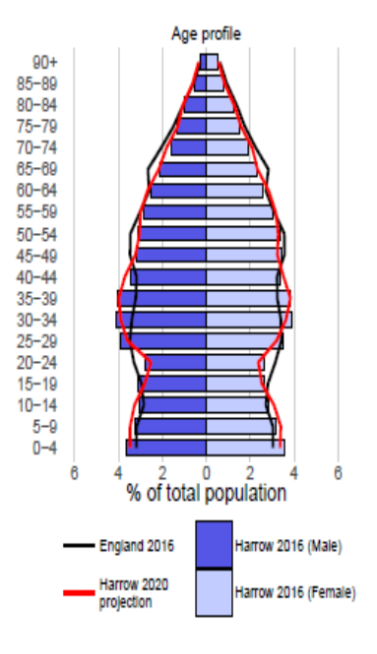
Population Growth: 7.1% of the population are aged 0-4; 13.4% aged 5-15; 64.7% are aged 16-64 and 14.8% are aged 65 plus. As with most areas in the country, the borough has an ageing population. There is an ageing population and it is expected that the number of residents aged 65 plus will increase by 38% and those aged 85 plus could increase by 60% by 2030.

Growing diversity: 42.6% of the population identify as Asian, which ranks 2nd nationally. Since 2001 there has been a 59.4% increase in the number of residents who are Asian. Harrow has a higher proportion of residents whose main language is not English and who cannot speak English or cannot speak English well, compared to the national and London averages.

Housing: Of the total amount of occupied dwellings in the area, 10% of Harrow’s households live in social rented housing. Harrow has the second lowest proportion of social housing of any of the London boroughs and 22% of households live in private rented accommodation. Around 2,000 households in housing need approached the Council for assistance in 2018/19, and the number of homeless families has increased over the past 5 years, with homelessness continuing to be a significant issue. There are also over 200 households living in bed and breakfast accommodation at any time. We will continue to work to help families remain in their accommodation whenever possible and find new housing solutions for families who need to move.

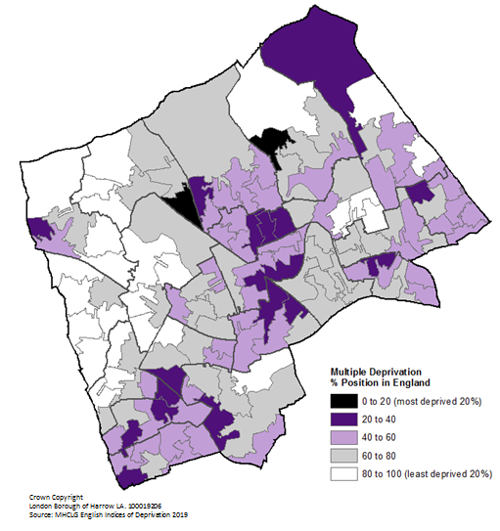
Housing Supply: There is insufficient provision of housing in Harrow to meet the growing needs of the borough. Current draft- proposed GLA targets require development of a further 802 homes per year over 10 years with affordable rent homes targeted towards existing residents to meet their needs (it is likely that this target may be increased). Key challenges are around low levels of genuinely affordable housing.

Deprivation: Within the borough, there are significant differences in our local communities with some areas amongst the most deprived in the country, while neighbouring streets can be amongst the most affluent. Whilst deprivation overall is improving, these contrasts in deprivation are increasing with 12.3% of children now living in deprivation across the borough.

Health: Within the borough, health is generally good, however, 14.6% of residents in Harrow have a limiting long-term illness or disability. This is an increase of 13.2% (+4,000) since 2001. Harrow’s rate is now higher than the average for London (14.2%). There is a widening gap of healthy life expectancy within the borough between men and women and the more and less deprived areas.

Healthy weight provides a challenge, with 22.5% of all 4-5 year olds are classified as over-weight and 9% of 4-5 year olds are considered obese. For 10-11 year olds, 34.5% are classified as over-weight, with 20% of 10-11 year olds classified as obese. This is higher than the national average, with the trend getting worse as children age.

Education: There are 62 schools in the borough, of which 92% are judged as good or outstanding by Ofsted. Despite population growth every Harrow child has been offered a school place at a Harrow school, achieved through our successfully delivered school expansion programme.

Crime: Over the past year crime levels have increased by 5%. The most common crime in the borough was anti-social behaviour although, relative to London, rates are low. The borough has a crime rate of 53 offences per 1,000 which is one of the best rates in London, making Harrow one of the safest boroughs in London: there is, however, a steady increase in crime levels and a disproportionately high fear of crime.

Environment: 40% of household waste was recycled in 2018/19, placing Harrow as 7th best London Borough, but there are high levels of fly-tipping which is partly linked to the rapid growth in numbers of Houses of Multiple Occupation (HMOs) and the capacity for them to effectively dispose of the amounts of waste created. An over-reliance on cars within the borough means that Harrow’s overall environmental performance is not good.

Employment and Skills: Unemployment to June 2019 was 4.1%: this is 0.5% below the London average. There are more than twice the number of residents with higher level qualifications in Harrow (37%), compared to those with no qualifications (17%). The borough also has one of the lowest levels of NEETs (not in education, employment or training) in both London and nationally.

Business: The borough used to be home to a number of large businesses, which have moved or closed over recent years, leaving sites vacant for re-development (contributing significantly to the increased housing provision required). There has been a decrease of 9,000 office spaces in the borough over the past year. Harrow is one of the boroughs in London with the highest concentration of microbusinesses which have contributed to a net rise in jobs. Start-up businesses benefit from a comparatively high success rate and move-on sites to support the development of new, local and sustainable business, with a growing need for further managed workspaces. The main employers in the borough are public sector, through the council, education and health providers.

Priorities and Outcomes
There are three foundations for maintenance / incremental improvement and five priorities presenting a significant challenge / requiring step-change improvement. Our challenges are set out over the following pages along with some of the evidence as to why they have been identified as a priority and the outcomes as a borough that we seek to change by 2030.

Improving the Environment and Addressing Climate Change
The challenges our global society and economy presents to the environment have been heavily publicised over the past year: it is important that in Harrow we contribute towards addressing these challenges by living in a more caring and sustainable manner. We need to change the way that we behave, reducing consumption of goods and minimising the impact of our lifestyles on our environment. This includes taking care to preserve and enhance our ‘natural capital’ (the soil, air, water and the vital but threatened ecosystems) upon which we depend. Everyone needs to contribute towards this challenge, which will mean some tough decisions over coming years, whilst maximising opportunities of new technology to live more sustainably, restoring nature and protecting our many parks and open spaces.

Our data tells us
With the increase in household costs for energy, it is important to ensure that those on low income are able benefit from energy-saving and cost reduction opportunities: contributing towards the climate emergency.
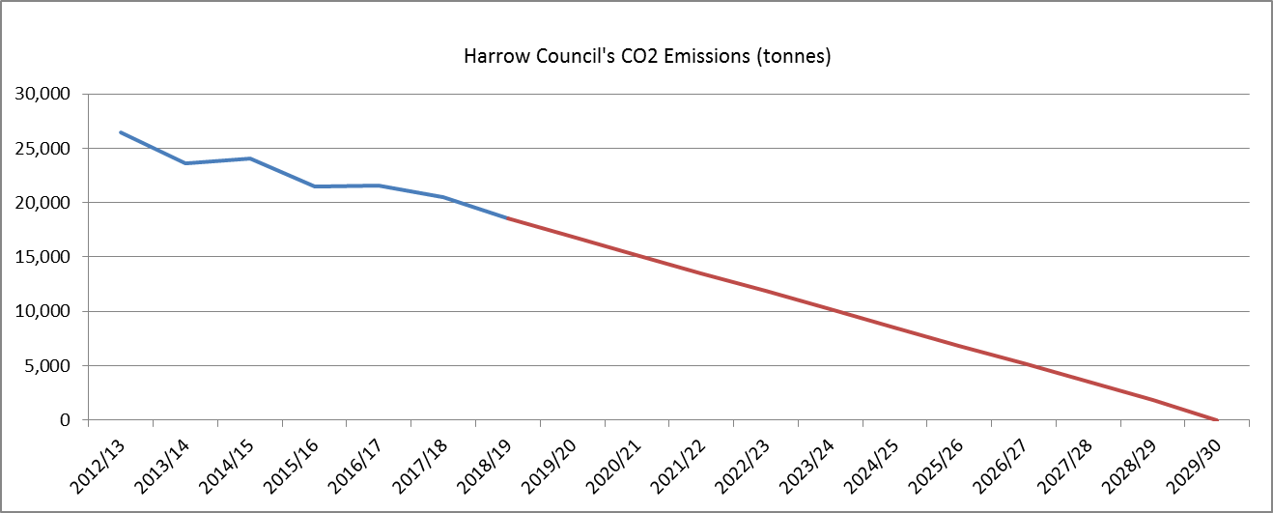
Reducing carbon emissions poses a significant challenge which the council, as an organisation, has been addressing for a number of years with solar panels on several schools, saving 16 tonnes on average of CO2 per year on a primary school. Many quick wins have been achieved, but an increased focus is required on the way we view our planet and how we reduce overall consumption of finite resources.
During 2018/19, 40% of the boroughs’ waste was recycled: to address the climate emergency, we need to focus on reducing the overall amount of waste produced, much of which has a high carbon footprint, as well as significantly increasing recycling rates across the borough.
Travel within the borough is predominantly by car: in 2018, there were 286 million miles driven by car within Harrow: this equates to more than 3,000 miles per household driven within the borough. With an over reliance on driving in the borough these savings in other CO2 emissions make a small impact on the overall carbon footprint of Harrow, with in-borough car usage accounting for around 2 million tonnes per year. Travel to school has shown an increase in rates of pupils walking, at 45% for 2018/19, shifting from those using public buses which has halved over the past 4 years. During the same period there has been no decline in the use of cars, standing at 27%.

Our proposed objectives
The key objectives we have identified for this priority are below, along with the issue we intend to address.
An attractive and healthy environment with improved streets, enhanced parks and accessible open spaces, providing relaxing recreation, supporting sport and active travel opportunities for all
  - Addressing sustainable transport and promoting a family friendly outer London borough
- Improving our access to clean air and water, and the other ecosystem services that are essential for us to all live healthy lives
  - Reducing residual waste and increasing recycling
Created modal shift in favour of sustainable transport – walking and cycling
  - Addressing over reliance on cars, reducing pollution and improving health
A net zero carbon borough by 2030
  - Addressing climate change and building a more sustainable borough
High quality parks and open spaces that are accessible to all
  - Green spaces enabling exercise and reducing carbon
High quality, energy efficient housing
  - Addressing fuel poverty, carbon emissions and heat loss causing global warming

The ‘Big Idea’
We will be one of the earlier London Boroughs to deliver on becoming net zero-carbon, achieving our target by 2030, ensuring that we tackle inequality through building more sustainable and resilient low carbon communities, making energy-saving measures available to those most in need: reducing fuel poverty.
We are also going to work to reduce significantly reduce waste at source and increase recycling levels across the borough so that Harrow is a more sustainable borough, minimising its overall impact on the planet.

How we will deliver our objectives
The Climate Change Strategy will be one of the key strategies with the Local Plan setting out requirements and expectations for all new buildings within the borough. The Sustainable Transport Strategy will be key in driving sustainable transport across the borough and setting out expectations from transport providers including Transport for London (TfL). These will be supported by the Infrastructure Strategy, providing a framework for much of the sustainable regeneration and development of our towns over the coming years.

Tackling Poverty and Inequality
We are a diverse borough with many areas of affluence and significant pockets of deprivation. We seek to make Harrow a more equitable borough, raising opportunities for those who are struggling and enabling everyone to live a full and rewarding life within their community.
We want to ensure that, as part of this growth, our communities are inclusive and opportunities are grasped to level up our more deprived neighbourhoods and groups.

Our data tells us
Debt levels in Harrow are significantly above London average and among the worst in the region, with those accessing support having individual unsecured debt levels at £16,389 per person compared to a London average of £11,616 per person. Alongside this, 61% of household income in Harrow goes on priority expenditure (compared to 57% within London).
The average household is paying 40% more for gas and electricity than they were five years ago, with overall household bills having grown by £2,707 a year over the period. This impacts on lower income households most of all and significantly increases the burden placed on poorer families or older people, with a significant increase in the proportion of their finances being spent on household running costs.
Harrow is a diverse borough with several areas in the most and least deprived areas. This means that the overall affluence of the borough masks a number of challenges within our specific local areas.
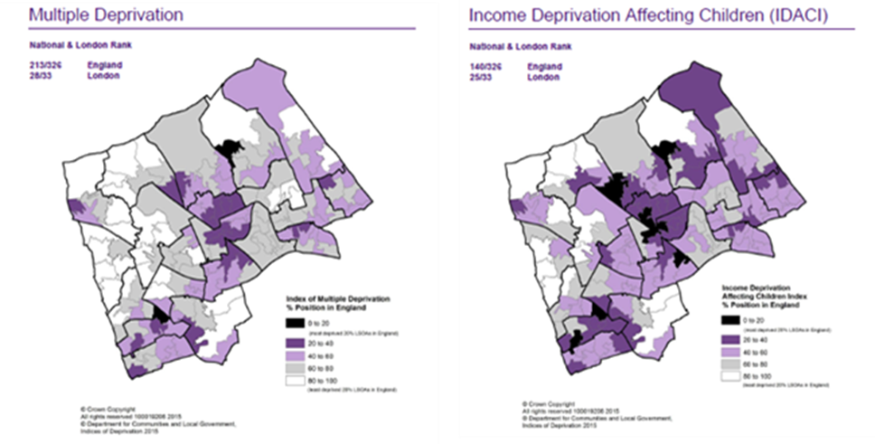

Our proposed objectives
The key objectives we have identified for this priority are below, along with the issue we intend to address.
All children are able to live homes where the family has the opportunity of earning a good household wage
  - Addressing child poverty
Everyone has a home suitable for their needs
  - Addressing homelessness and overcrowding
All people wanting to work have a job that pays above London Living Wage and are employed on a contract that meets their requirements
  - Addressing low pay rates and zero-hour contracts / gig economy and supporting financial stability
Households live free of unsustainable debt
  - Addressing high debt levels and the stress this causes

The ‘Big Idea’
We will tackle inequality by eradicating child poverty within the borough.
We are also going to work towards addressing low pay rates within the borough, enabling individuals and families to live a more rewarding life into retirement and enjoy the opportunities of living in a prosperous capital city.

How we will deliver our objectives
The Adult Learning Strategy will be fundamental in raising the skill levels of the local community and the current Regeneration Strategy will support attraction and growth of better paid jobs in the local economy. Over the coming year, we will develop an Inclusive Growth Strategy, replacing the Regeneration Strategy, detailing how we will deliver these objectives. These will be supported by our Infrastructure Strategy setting out the changes to the built environment over the next several years.

Building Homes and Infrastructure
There is a clear need for more housing, particularly social housing and affordable housing, across the country and London in particular. It is important for Harrow to contribute towards this increased housing provision, meeting our own needs and creating capacity for our growing population. We will put safety at the forefront of our thoughts, designing out crime: making our living and shopping areas safer and accessible to all.
To build communities it is essential that the investment in infrastructure such as medical provision, GP practices, police, employment / workspaces, sporting / cultural facilities and the improvement of parks and open spaces takes place at least in pace with any house building in order to enhance the quality of life of our residents. As communities grow and new housing is built, we will ensure that these are designed effectively to enable people to access town centres, jobs and other facilities using sustainable travel solutions: building in access to parks and new paths / cycling routes.

Our data tells us
There is a need for significant development of homes within the borough to meet the needs of individuals and families, with a projected population growth of around 50,000 over the next decade, taking Harrow’s population to around 300,000. At March 2019 there were 4,762 council properties and 4,327 housing association properties. Harrow is ranked 287th out of 326 local authority areas where rank 1 has the highest percentage of social housing: this evidences a lack of social housing and there is also little affordable housing within the borough (particularly for families). The diagram below shows the number and size of new affordable dwellings required in the borough to meet demand.
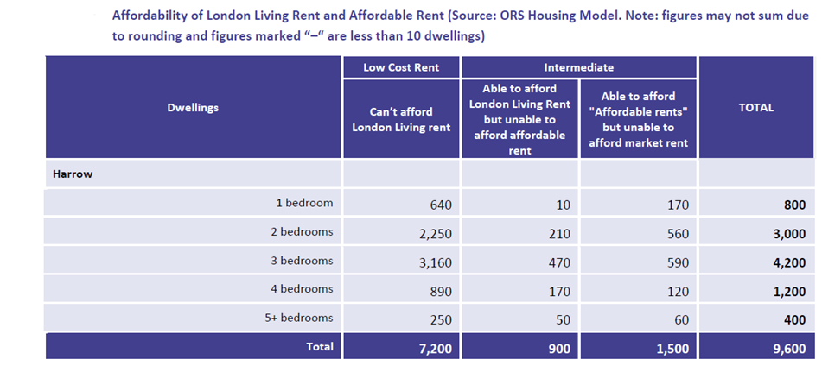
As with all London boroughs, there is a significant homelessness issue, in part due to a severe shortage of genuinely affordable housing.
The mayor has set a provisional target of 802 homes per year over the next decade (this is reduced from his original target of 1,392 homes, primarily as a result of work commissioned by Harrow on behalf of West London Authorities), which will help to provide much needed housing within the borough. Of these 8,020 new homes, almost half (3,750) should come from small sites, with a large number of the remaining homes to be constructed on sites that have already been identified. Around half of these are one-bedroom properties, which is out of line with the borough’s affordable housing requirements, where the average household occupancy of properties within the borough was last reported at 2.8 people and since that time, population has grown at a faster rate than housing provision (this was the second highest occupancy rate in the country).
There are estimated to be over 900 Houses of Multiple Occupation (HMOs), both registered and un-registered, largely within the east of the borough, many of which provide vital housing for people on lower incomes unable to rent a property of their own. There has been a 99% increase in HMO applications and 456% increase in suspected HMOs in the last 5 years: many un-registered HMOs are over-crowded, providing unacceptable living environments for their occupants.
Whilst data is held on the condition and energy ratings of social housing, there is little known about the actual condition of much of the private rented sector housing within the borough: this aspect contributes significantly to Harrow’s overall rental market. It is therefore likely that there will be a significant challenge in working with, and encouraging, this sector to improve the quality of homes to increase the energy efficiency and reduce heating costs, whilst also providing a better property for tenants to live in.

Our proposed objectives
The key objectives we have identified for this priority are below, along with the issue we intend to address.
All people able to live in the right size / tenure of home to meet their needs and expectations
  - Addressing overcrowding, lack of social housing and affordability challenges
Everyone has a quality, energy efficient and digitally-enabled home in a thriving community
  - Using regeneration to improve the quality as well as number of homes available
Neighbourhoods are integrated and well connected to thriving district centres
  - Addressing inequality and providing opportunities
Strong transport links and connections from housing areas that enable people to travel to their destination sustainably and safely
  - Addressing high car reliance, busy streets and pollution caused by travel
  - Enabling safe and healthy travel to schools, college or work

The ‘Big Idea’
Digital infrastructure delivered in line with house building across the borough will support tackling inequality by ensuring that communities are connected and businesses are able to benefit from SMART Cities technology.
We will also ensure through our planning proposals that our town and district centres are recognised as vibrant and multi-purpose places, supporting the local people in each of our communities.

How we will deliver our objectives
The Borough Wide Infrastructure Strategy, Local Plan and the Housing Strategy will be three of the key strategies supporting delivery of our new homes for the borough and the related infrastructure improvements that are required to provide safe, friendly and connected areas for people to live and flourish. We consulted on our Housing Strategy during 2019 and we will be consulting on the Local Plan during 2020 to ensure that it is able to deliver the expectations set out for the borough through the local planning framework.
We cannot deliver this priority alone and need to work with private sector landlords to encourage them to improve the overall standard of private rented accommodation within the borough: for many people this will be the only realistic way of securing the housing they need.

Addressing Health and Social Care Inequality
We understand the challenges faced by those living in loneliness and isolation and the impact that this can have on overall health and wellbeing. Harrow is in a great position to improve the health of our residents, with great access to a number of parks and open spaces providing opportunities for healthier lifestyles and recreational opportunities which are free for everyone.

Our data tells us
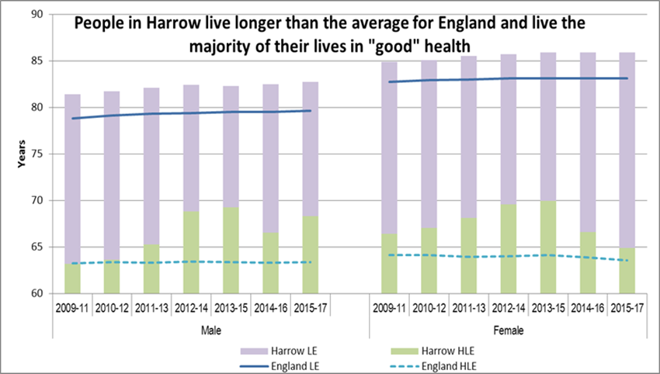
The government, within the Queen’s Speech, set a challenging target of increasing healthy life expectancy by 5 years by 2035: we will ensure that the government is held to account for this target and invests money in local services to enable this to be delivered. Our data shows that those with the longest unhealthy life expectancy are women and that healthy life expectancy is also lower in many of our more deprived areas.
Nationally, the numbers of people with dementia is projected to increase by 30% over the next decade: within Harrow our rate is also increasing, and is set to continue increasing at a pace over the coming years. Harrow has the seventh highest prevalence of dementia in London boroughs.
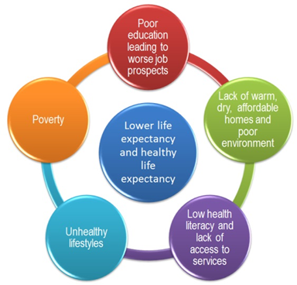
Diabetes is of particular importance in Harrow: there are currently 20,296 people registered as having diabetes (Type 1 or Type 2) with numbers expected to rise by 45% over the next 20 years. The latest primary care data shows nearly 10% of the adult population of Harrow to have diabetes, the highest rate in London. One of the main causes of type 2 diabetes is lack of exercise.
The Young Harrow Foundation / Council Needs Analysis in 2018 showed that physical activity significantly reduced as children hit their teen years. A high proportion of Harrow’s adult population are physically inactive (30% in 2017-18) which is the fifth highest inactivity rate in London.

Our proposed objectives
The key objectives we have identified for this priority are below, along with the issue we intend to address.
Increased healthy life expectancy for all, particularly those in disadvantage
  - Addressing the large gap in health inequalities between our residents from the least to the most deprived wards
Improved physical activity of all, irrespective of age, gender or ethnicity
  - Addressing poor levels of physical activity from an early age
All children experience a healthy start to life with good diet and appropriate exercise
  - Addressing obesity, low exercise and poor health / oral health
Families are strong and able to access early support where required, enabling them to be more self-sufficient and rely less on public services
  - Addressing reliance on social care and intervention to safeguard children
Increased numbers of elderly people able to continue to live at home
  - Addressing demand for high cost social care

The ‘Big Idea’
We will tackle inequality through reducing obesity: supporting improved levels of physical activity, enabling people to live longer and healthier lives whilst reducing the prevalence of diabetes within the borough.
We will also ensure that we become a dementia friendly borough to support the growing number of people affected by dementia, ensuring that they have a safe and engaging borough within which to continue their lives as independently as possible.

How we will deliver our objectives
The Health & Wellbeing Strategy will be one of the key strategies supporting delivery of our health improvements across the borough. This is supported by the Clinical Commissioning Group (CCG) and the Sustainability and Transformation Partnership (STP), setting out the role of the NHS and GPs in delivering against this agenda. Integration of health and social care will be a key enabler of these objectives, whilst improving the lived experience for our residents in the borough.
The Healthy Weight Strategy will support improvements in obesity and physical activity, contributing towards an overall improvement in health and life expectancy; while the Mental Health Strategy will be important in addressing this overall challenge: both are proposed to be developed during 2020.
We will encourage greater participation in cultural and leisure opportunities, as well as better use of our parks and open spaces, as a gateway to increasing physical activities and participation in sports to improve health and mental wellbeing.

Thriving Economy
A strong economy underpins a thriving borough, providing the business, employment and retail opportunities expected and required by our communities. The key challenge is addressing under-employment rather than unemployment – creating more and better paid jobs. We need to ensure that people are able to live, work, shop and participate in leisure activities within the borough: providing greater opportunities for everyone.

Our data tells us
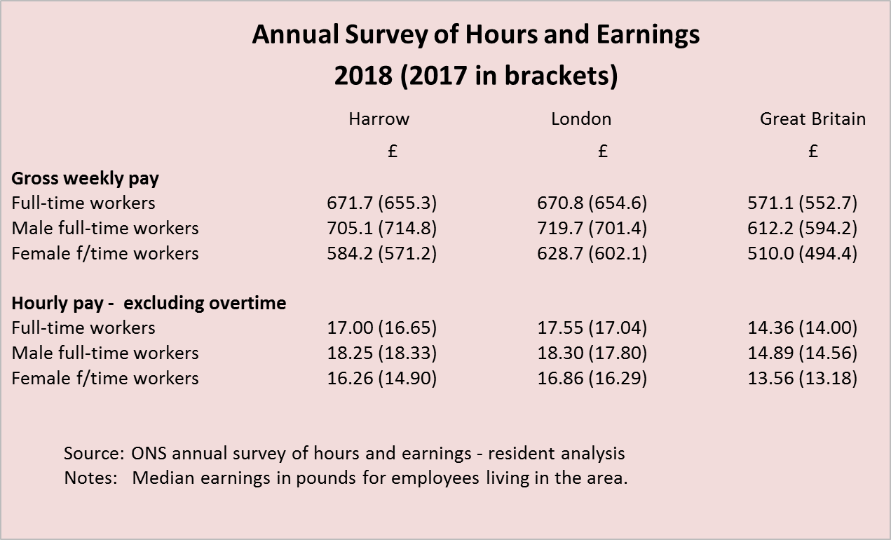
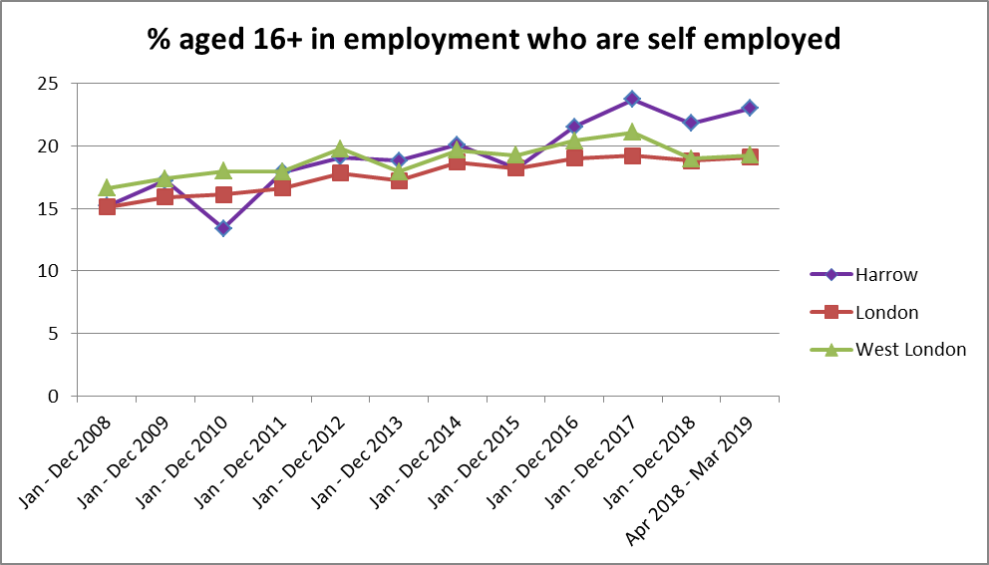
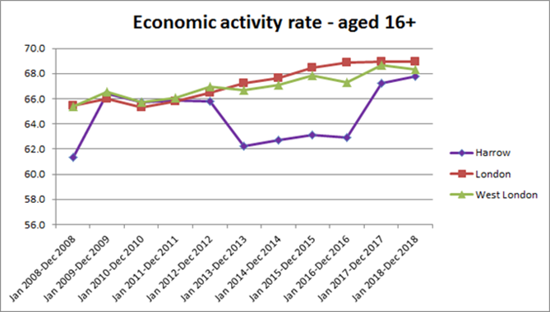
In Harrow, there are 80,000 jobs with a consistent growth over the past decade in people who are self-employed (now over 20,000): the business base is primarily small and microbusinesses, which tend to be less productive and pay less.
The economic activity rate for people in Harrow has been significantly below London for a number of years, but the gap has closed since 2017. Part time work has grown by 8% over the past 3 years, with a corresponding reduction of 6.25% in full time employment.
There is a large gap in earnings between men and women, and those working outside of the borough earning more than those employed within the borough. This shows that men earn almost £15 per week less than in London whilst women earn over £44 per week less. An aspect of the gap in earnings between those in and out of borough is due to the nature of the self-employed and SME economy locally, with all remaining larger employers within the borough being public sector.
Over the past year, there have been 9,000 office spaces lost within the borough.

Our proposed objectives
The key objectives we have identified for this priority are below, along with the issue we intend to address.
High earning jobs within the borough
  - Addressing low paid employment in borough
Micro, Small and Medium sized enterprises grow sustainably within the borough
  - Addressing employment and encouraging entrepreneurialism
Employment opportunities to match skills available within the borough
  - Addressing need to travel for suitable employment
Local learning / skills opportunities match business needs / sectors
  - Addressing lower earnings and the need to travel for suitable employment
Vibrant town and district centres
  - Addressing high street decline and loss of local spend

The ‘Big Idea’
Harrow will tackle inequality through improved transport links such as Crossrail 3, orbital links and new bus routes, supporting access to and between our town centres and employment sites to support our economy and attracting more commercial and office space.
We will also work with partners to sustain our high rates of business survival and support business growth within the borough to raise local earning levels and provide local jobs for our residents.

How we will deliver our objectives
The new Inclusive Growth Strategy will be one of the key strategies supporting delivery of our thriving economy whilst the Adult Learning Strategy will support delivery of the need to raise the skill levels of many adults within the borough to enable them to meet their earnings and employment aspirations.
The Business Forum will play an active role in supporting identification and delivery of priorities as well as prioritising improvements and harnessing the support of local businesses to meet our shared objectives.

Sustaining Quality Education and Training
Currently our schools are highly rated and perform well overall, but we want to ensure that everyone benefits from the education system to achieve the best they can.

Our data tells us
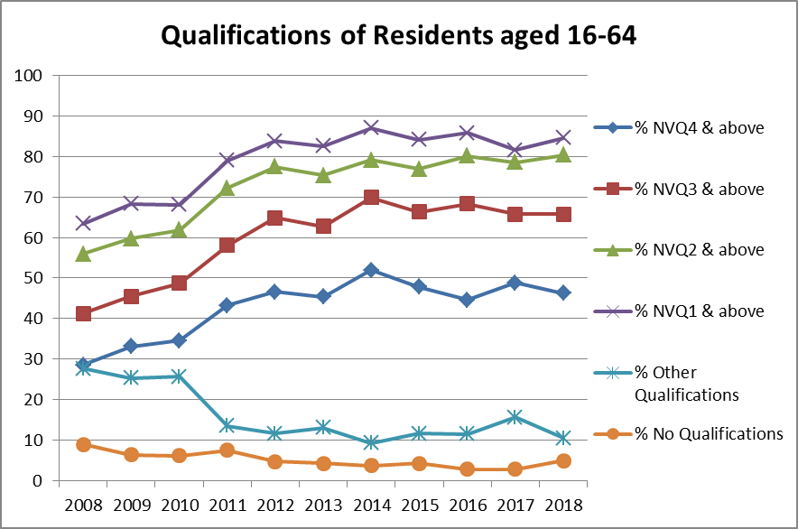
Overall our pupils perform well, but some groups do not attain the same standard as their peers. These groups include: looked after children; Unaccompanied Asylum Seeking Children (UASC); black boys; and white boys from more deprived areas.
Comparing attainment data over time is difficult due to changed exam systems, but our provisional 2019 average Attainment 8 score of 50.8 is better than pupils in London (50.2) and nationally (46.7), but behind statistical neighbour’s score of 52.8, which demonstrates the scale of improvement required for our lower attaining cohorts of pupils.
Employment, Education and Training (EET) rates are amongst the very best in England and are sustained at around 99% for local young people aged 16-18.

Our proposed objectives
The key objectives we have identified for this priority are below, along with the issue we intend to address.
All schools, colleges and other educational settings are rated as good or outstanding
  - Addressing inconsistent educational opportunities
All underachieving groups achieve in line with or better than their peers
  - Addressing the attainment gap
All people have the level of qualifications required to meet their employment aspirations
  - Addressing low pay employment and poverty
Everyone is able to benefit from lifelong learning, training and enrichment opportunities
  - Addressing poverty and improved mental health

The ‘Big Idea’
We will tackle inequality by addressing the attainment gap: ensuring that underachieving groups all perform in line with, or better than, their peers.
We also want to attract a university for Harrow and strengthen relationships with the colleges to ensure a coherent post-school offer in the borough for everyone.

How we will deliver our objectives
Schools within the borough will be key to delivering on these objectives and the Adult Learning Strategy will be one of the key strategies supporting the delivery of a high quality education system that works for everyone.

Celebrating Communities and Cohesion
The nature of our borough and the communities it comprises of has changed over the past decades, and will continue to change into the future. We are determined to work with our communities to ensure that they are able to benefit the most from living here and contributing towards the improvement and diversity of our area.

Our data tells us
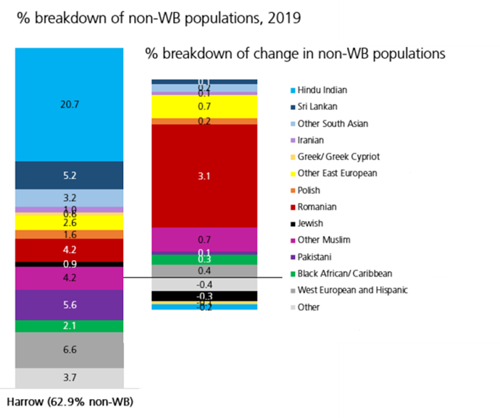
Harrow is a diverse borough, with a growing non-white British population and has the fastest growing Romanian population in the country. The Hindu Indian population has traditionally been the largest non-White British community in the borough, however, now the European community accounts for a similar proportion of the population at around 20%. The Eastern European population now accounts for two thirds of the overall European population and Romanians represent two thirds of the Eastern European community.
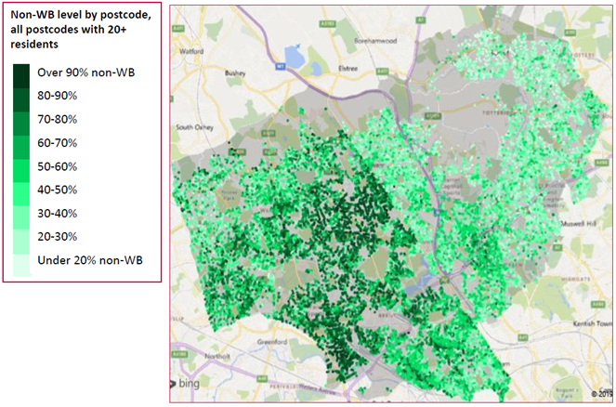
Many new or evolving populations will focus their growth on particular areas of the borough, potentially causing tension with the established population who perceive their community to be changing. We value the growing diversity of our communities and the increased Eastern European population as well as the high levels of Asian communities which have been well-established within the borough.
While many areas have seen reduced levels of public engagement and lower election turnout, people in Harrow have tended to vote, with turnout at recent council elections being 41%.

Our proposed objectives
The key objectives we have identified for this priority are below, along with the issue we intend to address.
A thriving, multicultural borough where events support our communities continued integration and values
  - Addressing community cohesion
Everyone takes an individual and collective responsibility for building good relationships within their community
  - Addressing tensions between communities leading to isolation
Our annual resident’s survey demonstrates a continued increase in people feeling that communities get on well together
  - Addressing intolerance and supporting cohesion
Maintaining high levels of civic engagement
  - Ensuring we retain high election turnout among all our communities
  - Growing the numbers of people active in public life and community roles

The ‘Big Idea’
We will tackle inequality through improving the environment and living standards within our more deprived communities: affording them a better quality of life.
We will continue to work with our communities, culturally and geographically, to help them inform and support development of their locality to deliver their aspirations. We will also look to recognise our diverse and cohesive communities through becoming a Borough of Culture.

How we will deliver our objectives
The Wealdstone Action Group (WAG) and Community Action South Harrow (CASH) will be fundamental in supporting plans in these areas. During the life of this plan we will also be undertaking specific and targeted work within Edgware and the east of the borough in response to demand.

Maintaining Low Crime Levels and Improving Community Safety
Whilst there are low levels of crime compared to neighbouring and other London boroughs, we are not complacent and want to see crime levels fall, recognising the impact that any crime has on victims. In some types of violent crime we have seen a rising trend, in line with London and national trends: we are eager to reverse this. We are also committed to improving community safety and the perception of crime to ensure that everyone feels safe and able to live a full and rewarding life in the borough without fear of crime.

Our data tells us
In the year to July 2019 there has been a 16% increase in total crime offence levels within Harrow, although the overall rates remain lower than most other London boroughs.
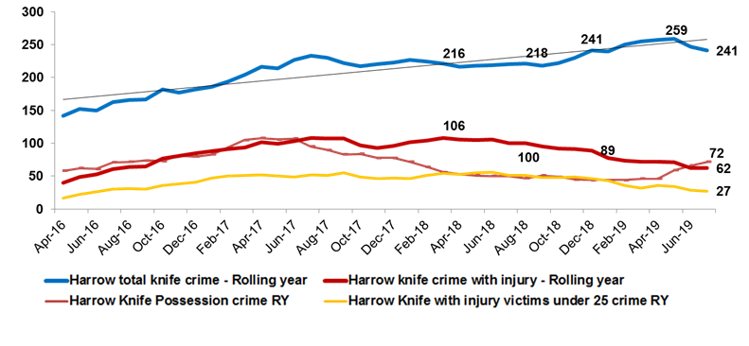
Across London tackling knife crime is a priority: within Harrow there has been an increase in knife crime, although at a slower rate than London. Over the past two years, there has also been a reduction in injury caused by knives, but these levels remain too high.

Our proposed objectives
The key objectives we have identified for this priority are below, along with the issue we intend to address.
Low levels of crime within the borough
  - Addressing community safety and crime levels
Everyone feels safe within the borough and our town centres throughout the day and at night
  - Addressing fear of crime and making greatest use of our town / district centres
Children and young people are able to grow up safely and without fear of abuse or exploitation
  - Addressing County Lines and child sexual exploitation

The ‘Big Idea’
We will tackle inequality through working to protect our children and young people from County Lines, raising awareness of the threats and engaging children at a younger age to enable them to make informed choices.
We are going to create vibrant and multi-purpose town centres that are welcoming and make people feel safe.

How we will deliver our objectives
The Violence, Vulnerability and Exploitation (VVE) Strategy will be one of the key strategies supporting delivery of community safety across the borough. This strategy is being refreshed early in 2020 and will contain shorter term targets for tackling our immediate crime challenges in line with the London Mayor’s priorities, but will also have a large focus on addressing fear of crime across the borough.

Next Steps
During 2020 we are committed to engaging with more people in informing the Borough Plan. This will allow us to hear feedback about the priorities, gain information to support developing the actions to deliver our priorities and engage others to take lead roles in delivering these changes within the borough. We are determined that this engagement will be an ongoing rather than a one-off process and as such, we are eager to understand: where resident priorities lie; what may be “quick wins”; how we are able to collectively deliver against our more challenging ambitions; and how we gauge progress in improving the borough we care for.
To ensure that we do this, we will be developing a partner engagement plan and a resident engagement plan, providing opportunities for more people to contribute towards the focussing and delivery of our shared aspirations for Harrow.
Much of what we seek to achieve requires us to work in partnership: a few things we can deliver for ourselves whilst most will require collaborative working and us to collectively influence others to support our changes… As such, our final plan will be led and signed up to not just by the council, but our key partners in health, police, fire, education and the voluntary and community sectors: together, we can turn our plan into our future.

Short term delivery plan
To ensure that work continues throughout our year of engagement, we are creating a short term delivery plan for the council’s contributions, focussed on delivery of the priorities and objectives we are consulting on.
This provides an opportunity to focus on some of the short-term challenges that have been raised and through delivering some of these, enabling us to be in a better position to deliver against the longer term ambitions.

Source POPPI Population projections 2019
Income Deprivation Affecting Children (IDACI) Data, Ministry of Housing, Communities & Local Government, 2019
Department for Transport – road traffic statistics
Comparethemarket.com December 2019
ONS Analysis of 2011 Census

